Q3)Explore packet filters using TCP-dump,Wireshark,Cisco Packet Tracer

1)Wireshark:

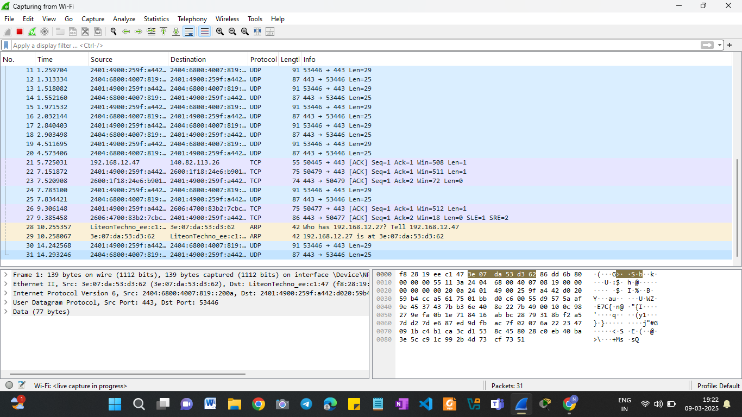
Using Options:
- http || tls
• http → Shows unencrypted HTTP requests.
• tls → Shows encrypted HTTPS traffic.
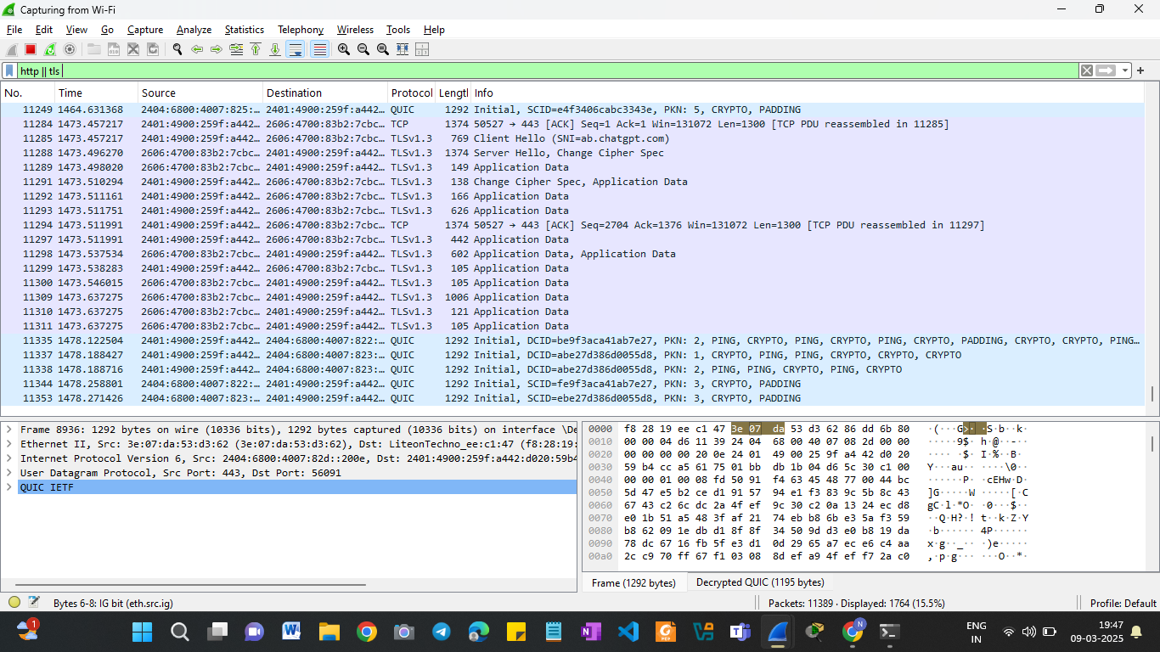

- tcp: To show only TCP packets
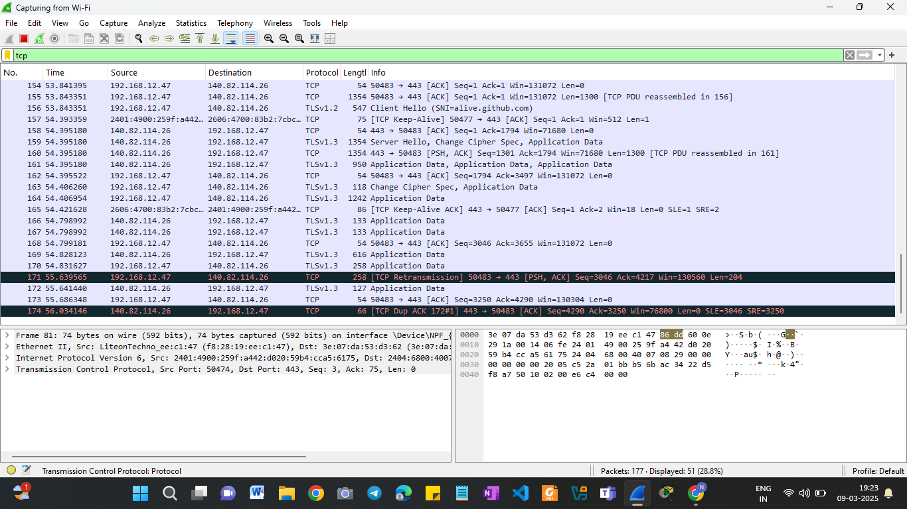

- icmp: show only ICMP packets (ping requests)

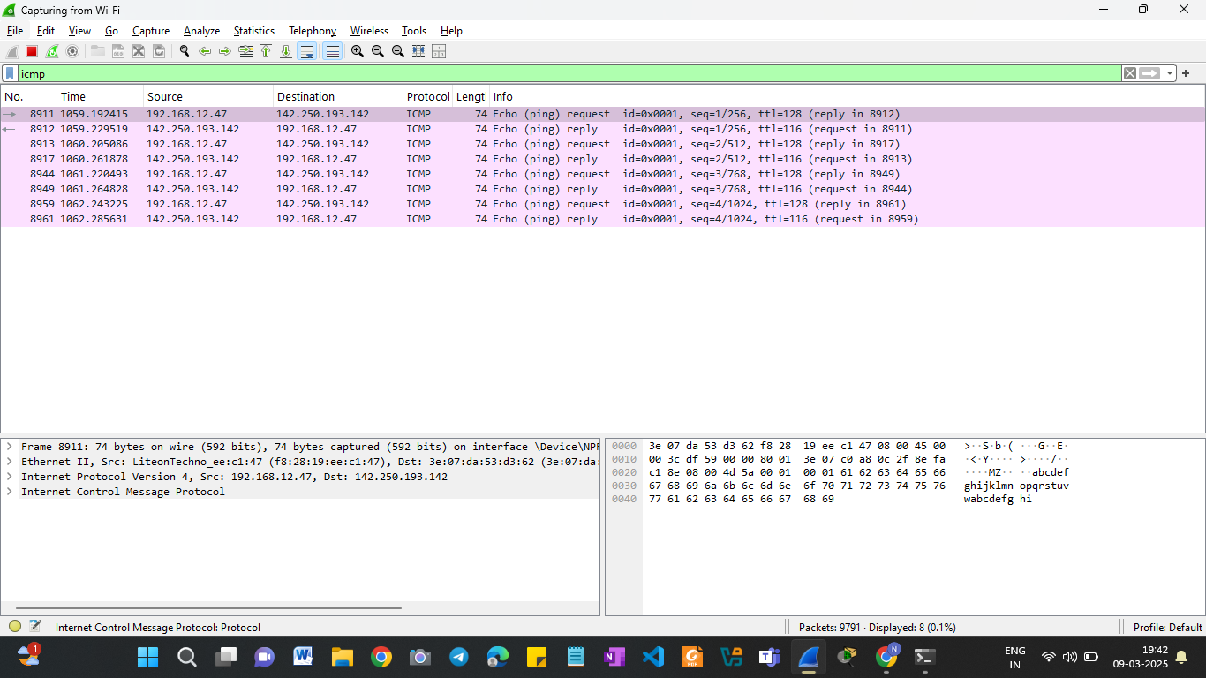

2)TCP –dump:
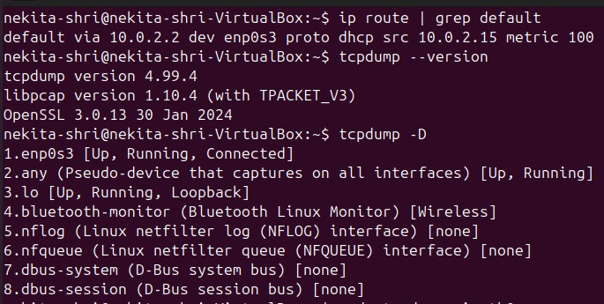

3)Cisco Packet Tracer :
- Simple P2P network:
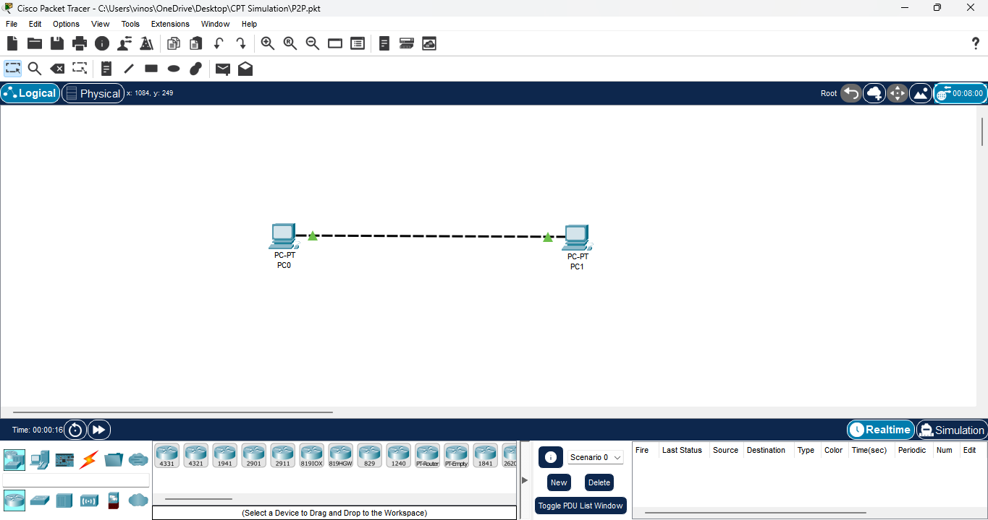

- Use of HUB:

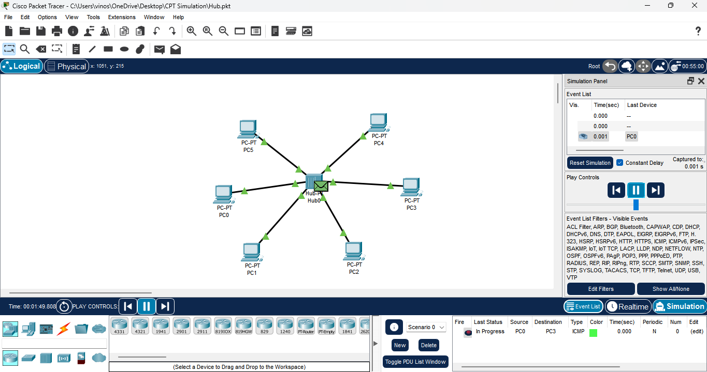

- Use of Router
